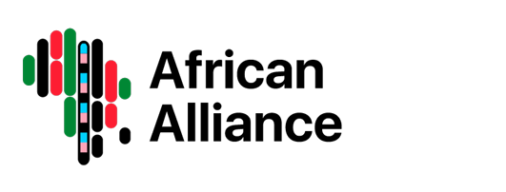

AFRICAN ALLIANCE MEDIA STATEMENT
Big news from the world of HIV vaccine research
For Immediate Release
19 May 2025, Johannesburg — We welcome the exciting news released today by the non-profit research lab IAVI and its partners on the success of two groundbreaking HIV vaccine trials that mark a true breakthrough in the decades-long fight against HIV.
For the first time, scientists have shown that it’s possible to coax the human immune system into making broadly neutralising antibodies (bnAbs) with a two-dose schedule of injections.
Broadly neutralising antibodies are potent germ fighting proteins produced by the immune system which are capable of identifying and vanquishing many different variants of HIV.
This is a powerful scientific milestone because it offers hope that we’re getting closer to an end to HIV, a virus that evaded cure for decades.
What makes IAVI’s announcement remarkable is that they’ve discovered the beginnings of a way to teach the immune system to catch and kill HIV, without ever exposing the person to the virus itself. Under usual circumstances, the body’s army of fighter cells “remember” an old foe and then send out specific fighters that know exactly how to wipe out the invader.
These IAVI studies instead train the immune system to take down HIV before the person is ever exposed to the virus. This is called “germline targeting”.
This approach, though still in early stages, lays critical groundwork for developing an effective preventive HIV vaccine. The ability to reliably induce bnAb precursors (so, the vaccines can trigger the body to make HIV-fighting antibodies) represents one of the clearest advances we’ve seen in the field.
We are particularly encouraged that this progress was demonstrated in both North American and African trial sites. This suggests that the approach has the potential to work across diverse populations an essential requirement for a truly global HIV vaccine.
The paper, which was published in the journal Science on 15 May, has just under listed 100 authors, which is a testament to the critical role of inclusive, collaborative research that bridges communities, continents, and disciplines.
To the researchers, trial participants, and partner institutions around the world including the Aurum Instittute in South Africa and Rwanda’s Centre for Family Health Research, the National Institutes of Health and the President’s Emergency Plan for AIDS Relief among others, thank you.
Your work brings us one step closer to a world free of HIV.
While more trials are needed before a vaccine is available, today’s announcement gives renewed hope to millions still affected by HIV.
The scientific community has taken a major step forward and with it, our collective dream of ending AIDS becomes more achievable than ever.

