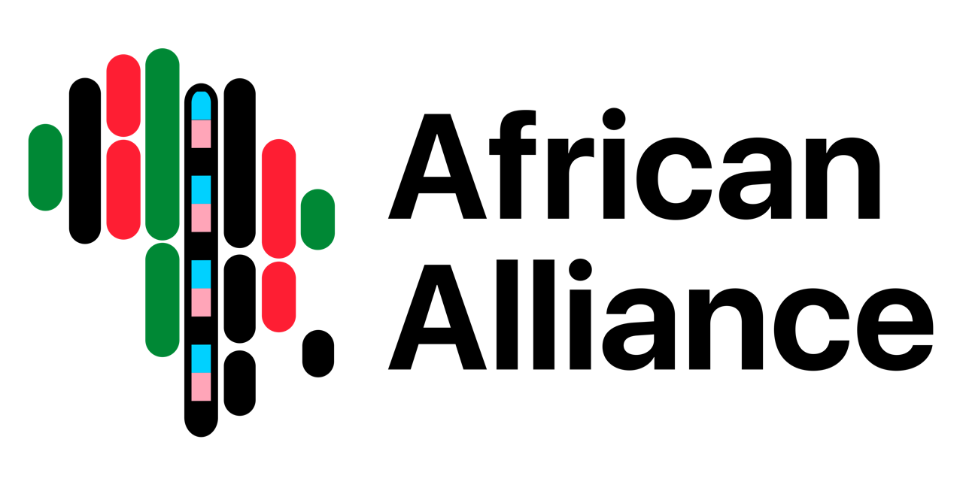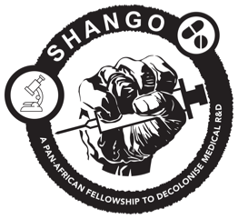

For Immediate Release

10 African revolutionaries gather in Kigali to disrupt R&D

Kigali, Rwanda — 26 April 2024 — This week, 10 revolutionary African thinkers gathered at the historic Hôtel des Mille Collines in Kigali’s city centre, which served as a refuge during Rwanda’s 1994 genocide. Their mission was to come up with ways to disrupt and decolonise the world of medical research and development. They leave Kigali today, each armed with proposals that detail their vision of a reimagined, decolonised, completely African public health sector.

These comrades represent the inaugural class of the SHANGO! fellowship, a groundbreaking project made possible by the African Alliance in partnership with Open Society Foundations.

SHANGO! came about as a reaction to the Alliance’s experience during the COVID-19 pandemic.

“We were invited into conversations with influential decision-makers and then had to sit through meetings in which we heard that Africans couldn’t be trusted with vaccine roll-outs because they would steal the storage fridges and shun the jabs,” says Tian Johnson, founder and strategist of the African Alliance.

Johnson came out of these meetings with a fresh understanding of how futile it is to ask for humane treatment from a system that has long dismissed the humanity of Africans. “We thought about the next pandemic and wondered whether we’d be sitting in demeaning meetings then as well.”

“I dreamed of an Africa that doesn’t rely on Western donors, an Africa with its own, unique and vibrant research circuit that celebrates academic work written by Africans, published in African journals with enough funding, and medicines developed on the continent and distributed in partnership with the community.”

What would it take to make these dreams a reality?

That answer will come from the SHANGO! Fellows, who represent a variety of fields from emergency medicine to pharmacology to law and linguistics.

Their ideas will be released as part of a dedicated publication and in the popular press in the coming months.

John Beku, a public health consultant and facilitator for the fellowship says SHANGO! is unique in its approach because it gives people the space and time that is required to do the work of decolonisation, whether it be to mourn, to learn, to dream or to disrupt.

“I’m excited about the commitment the fellows have shown to reimagining what is possible for Africa’s future,” says SHANGO fellowship lead professor Morenike Ukpong, who is a veteran of the HIV research field.

For more information contact:

Ingrid Tagwireyi: ingrid@africanalliance.org.za

